**Result of python_test2_question2_karthik.py**

**Initial Dataset**

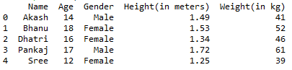

**Ascending order in terms of height**

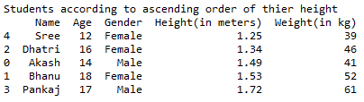

**BMI**

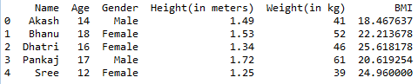

**Status based on BMI**

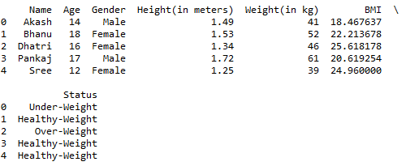

**Grouping**

